Assignment-3

Q1

a. Maximum expected value (theoretical) of throughput (in Mbps) is 7mbps, because value of bottleneck link is 5mbps which link between two links. Hence, maximum throughput is 7mbps

b.

**Formula for BDP**

**Bandwidth Delay Product = RTT(Round Trip Time)*Bandwidth**

Total bandwidth = 5mbps

d1(b/w node0 and node1) =100ms

d2(b/w node1 and node2) = 10ms

Total Delay = d1+d2 = 110ms

RTT = 2*110= 220ms

Bandwidth Delay Product = 5mbps * 220ms = 1100 kb = 1100000 bits

Application payload size = 1460 Bytes

= 1460 * 8 bits

Number of packets = Bandwidth/Application payload size

=1100000/ (1460 * 8) = 1100000/ 11680 = 94.1packets

c. The average computed throughput of the TCP transfer is 3088kbits/s which is equal to 3.088mbps.

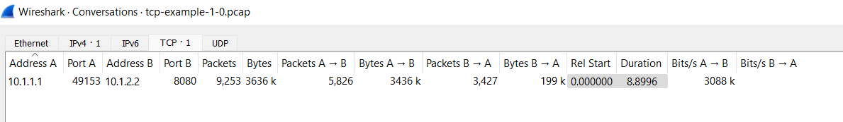

d. No, achieved throughput approximately is not equal to the maximum expected value. Because we usually ignore delay but in actual there is some delay like transmission delay, queuing delay, network congestion etc during transmission of data. So, that why it is sightly lower than maximum throughput.

e. 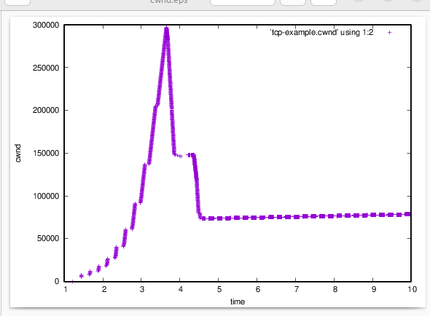

f.

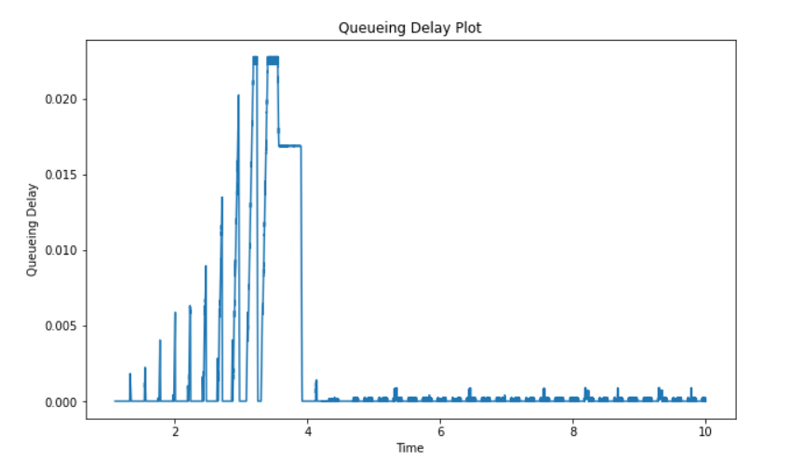

g. Yes, the plot are related as it grew proportionally to the size of the congestion window as if we increase the congestion window size, queuing delay is also increases. After, 4 sec it became constant.

Q2.

a. Average computed throughput of the TCP transfer is 4506k and 4.506 Mbps

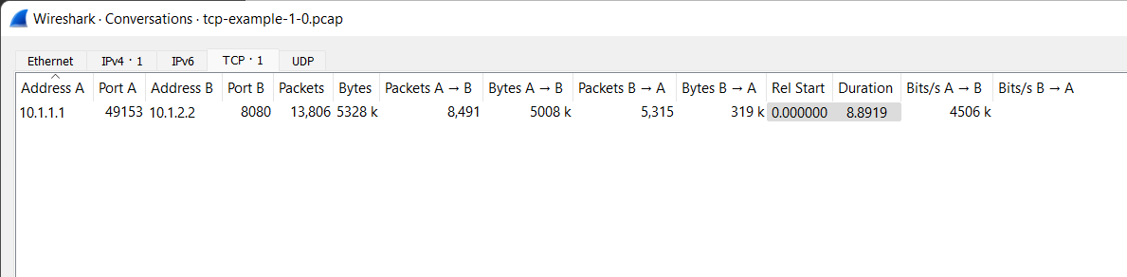

b. 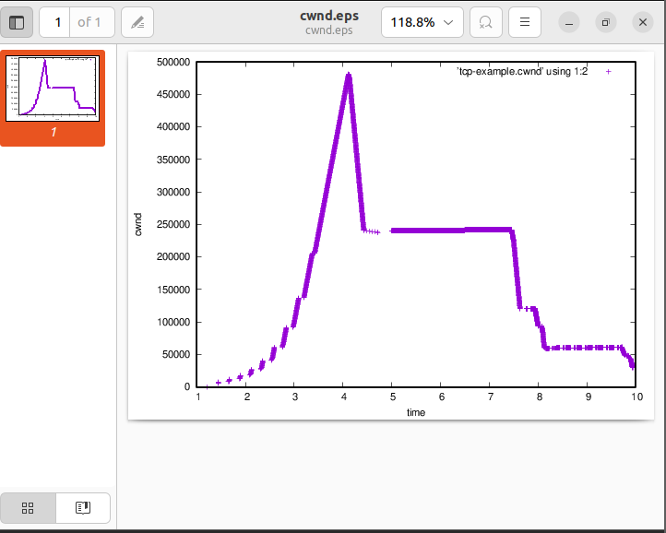

c.

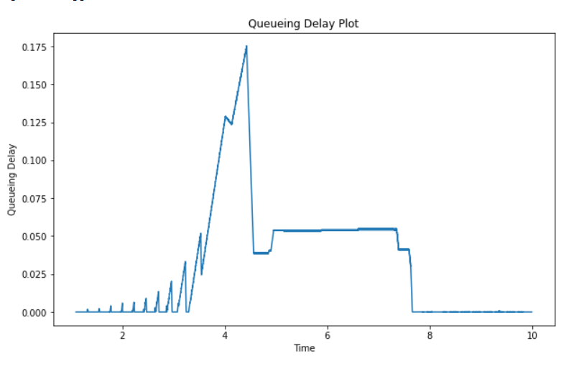

d. Now, we have increased queue size, which will allow more packets capacity hence due to this we can store more packets in queue i.e send more packets, thus increasing congestion size.

Now, congestion size is higher in question2 compared to question1 because queue size is increased then packets have to wait for a longer time in order to be transmitted, hence resulting in increased congestion window size and queuing delay.

Q3.

a.

Average computed throughput of the TCP transfer is 3813k and 3.813 Mbps

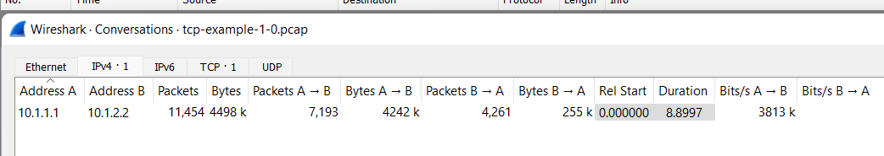

b.

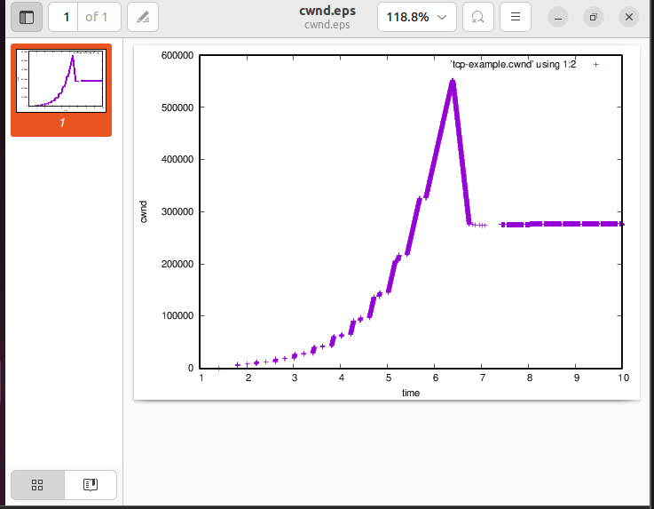

c.

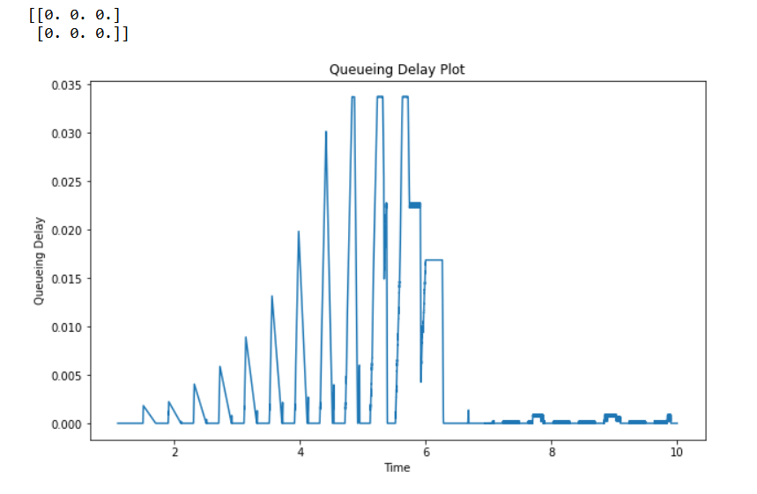

d. Now, we have increased bandwidth to 10mbps and decrease the delay to 100ms. So, it can lead to delay in packets travel from N1-N2. That can lead to reduction in packet transmission capacity. So, this will result in reduced transmission rate as TCP affected Congestion at the end of node N1 is decreased, hence the transmission rate increases. Thus, all of this is observed in the above plot, which demonstrates an increase in the cwnd size with respect to Q1.